**INSTALLATION REQUIREMENTS:**

* NodeJS
* Appium
* JDK
* Maven

**MAVEN COMMAND TO EXECUTE:**

mvn test verify -DdeviceName=GalaxyS10e -Dcucumber.options="--tags @auto"

**APPIUM LOGS:**

\\src\\test\\java\\Logs\\ApplicationLog

**REPORT LOCATION:**

//target//report//cucumber-html-reports//report-feature_3867371660.html

**Evidence1 - BUILD SUCCESS**

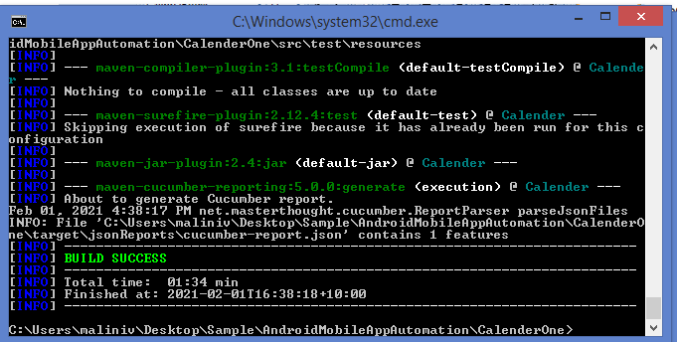

**Evidence2 - REPORT:**

